How To Make Your Own Six Yard Bell Target Mechanism
Plunger
Glossary of Terms:-
Top Guide
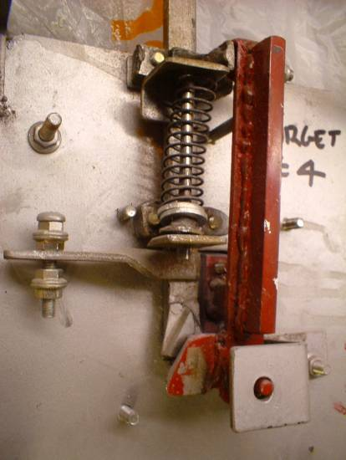
Pendulum Bracket
Pendulum
Mainspring
Mainspring Guide
Plunger Spring Bracket
Bottom Guide
Lower Spring Bracket
Bell Striker Bracket
Bell Striker
Plunger Sear
Pendulum Sear
Pendulum Spring Bracket
Mounting Screw For Bell
Front Plate
Notes:-

All dimensions in the explanatory text are in millimetres.
Any thickness material can be used, but adjust the relevant dimensions to suit.
All parts are made from the same thickness plate.
Make any clearance holes maximum 0.25 mm larger than the fixing going through it.

I tried writing this from memory using an old target that I had made about 12 years ago pictured above, as a memory jogger, but it didn’t work out. What I have done is actually make a new one and document it as I go along.

Hope you can follow it.

Neil

- Front Plate

Material is mild steel plate with a minimum thickness of 2 millimetres. Cut this into a square with 200mm sides.

In the centre of the square cut a rectangular hole 25mm x 50mm - fig # 1.

To achieve this cut-out I usually drill a series of small holes around the inner edge to remove the bulk of the material and then finish off the rectangular shape with a file – fig # 2.

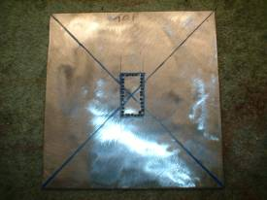
fig # 1 – Front Plate
Drill Holes

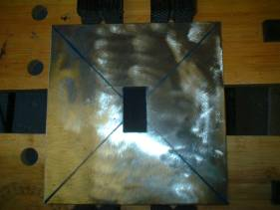
fig # 2 Cut-out

Remove all burrs and sharp edges with a file.

- Plunger.

Cut a strip of 2 to 3 mm thick mild steel into a rectangular strip 20mm x 160mm. Make sure that the 20mm dimension is as straight and parallel as possible. Fig # 3

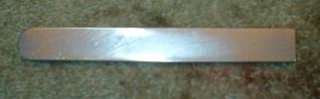
fig #3 - plunger

Round off the top and take the sharp edges off the long sides and use emery paper to smooth all surfaces.

3. Guides:-

From the same thickness material that the plunger was cut from, cut two strips 20mm x 36mm and two strips 20mm x 8mm. Clamp one of the 36mm strips and the two 8mm strips together as in fig # 4 to make a “sandwich” with the plunger in the centre and then carefully weld around the joint lines ensuring that you do not weld the plunger into the guide.

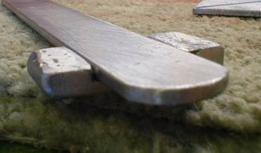
fig # 4 - Guide
Clean off the excess weld and splatter with a file

Weld Weld

You should then after removing the plunger have one wide guide looking like this – fig # 5:-

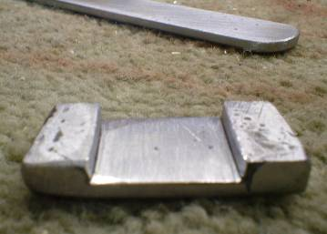
Fig # 5
Weld Lines after filing off excess.

You then cut this wide guide through the centre with a hacksaw where the dashed line indicates to end up with two guides about 10mm wide. File the sawn edges smooth and remove all burrs and sharp corners.

Now cut the remaining 20mm x 36mm strip along its long centreline and file smooth and de-burr so that when they are placed together with the above assemblies you have two complete guides – fig # 6
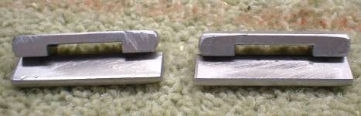
fig # 6- Guides
Fixing The Guides To The Front Plate:-

There are two alternative methods of fixing the guide assemblies to the front plate:-

- Drill and tap the welded assemblies and use short bolts.
- Drill clearance holes through the whole assemblies and fix with small bolts and lock-nuts.

Ideal sizes for the bolts are either 2BA or 5 millimetres.

I am using method ‘a’ with 5mm diameter bolts and nuts where appropriate.
Fig # 7
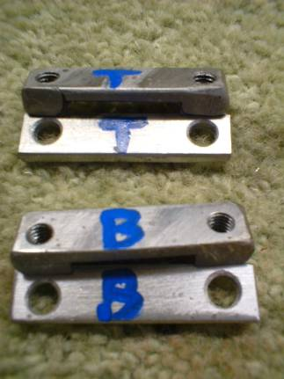
Holes drilled and tapped 5mm
Clearance Holes

Method ‘a’

Drill and tap the welded assemblies in the centre of the 8mm side pieces with the appropriate thread. In the corresponding plate, drill clearance holes for the bolts in the same place as the welded assembly.
Method ‘b’

Drill clearance holes in the centre of the 8mm side pieces through the whole assemblies.

Top Guide:-

Position the top of the top guide flush with the top of the front plate, with the plunger running perpendicular down the plate, in line with the left hand longer side of the cut-out.

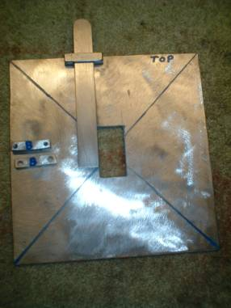

Mark the position of the existing holes in the top guide onto the front plate. It will be wise at this point to mark the top guide in some way to identify it’s orientation on the front plate as it can go two ways and if your manufacture of the guide is not exact then it will only fit correctly if replaced in the same orientation as the holes have been marked through. You will see in a previous photograph that I have already identified them.

Centre-punch the position of the two marked positions on the front plate and drill through with appropriate clearance holes for the bolts being used. Be-burr the holes with a larger drill or a chamfering tool.

Fix the top guide in position using either the bolts only or the bolts and nuts.

Try the plunger in the closed slot that has now been formed. This should be a loose sliding fit with no snagging or resistance. Invariably it will be tight when first tried, but this can be overcome by filing the sides and top and bottom of the slot and the high points on the side of the plunger with a smooth file until the correct fit has been achieved.

Tip:- remember you can dismantle this to file it, don’t to try to do it in situ…….

Bottom Guide:-

Mark the positions of the fixing holes for the target plate. Make sure that you get the plate exactly in the centre of the back plate and the fixing holes are aligned across the plate.

Identify the top of the bottom guide and position the top edge 61mm down from the top edge of the front plate, maintaining the plunger parallel to the side of the front plate.

If you have worked accurately then the left hand fixing hole in the bottom guide should be in exactly the same position as the top left fixing for the plate when viewed from the back. This is intentional. If they do not line up exactly then move either the plate position, the bottom guide position, or a bit of both until you get them to coincide with each other. A couple of millimetres out will make no difference to the function of the target. Now drill four clearance holes for the target plate fixings.

Although we are using this hole for fixing the bottom guide at the moment, later we will drill the left hand tapped hole in the bottom guide out to make a clearance hole and a bolt will go through the guide from the back, through the back plate and will screw into one of the target plate support pillars.
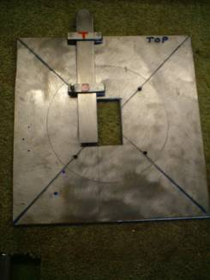
61mm
Common Fixing

Secure the bottom guide with a bolt through the target plate fixing hole and, mark the position of the remaining fixing hole, drill the clearance hole, de-burr and fix with the appropriate fixing.
Try the plunger in the pair of closed slots that have now been formed. Again it will be tight when first tried, but this can be overcome by more filing of the sides and top and bottom of the slot in the bottom guide with a smooth file until the correct fit has been achieved.

4. Pendulum Bracket:-

Bend a 10mm wide strip of plate into an ‘L’ shape, the longer side being 25mm and the shorter side 18mm. Place this on the back of the top guide with the longer leg on the guide and the shorter leg to the right hand side. Scribe a line on the shorter leg that is 20mm from the back of the front plate. Centre punch in the middle of the 10mm width and the scribed line and drill a clearance bole for a fulcrum bolt. De-burr the hole and insert a bolt 30mm long through the hole. Weld the head of the long bolt to the bracket.
Weld this assembly onto the top guide so that the end of the 25mm length is flush with the left hand edge of the top guide.
We have now covered over the left hand upper guide fixing hole. Drill through and tap through the new part of the hole.
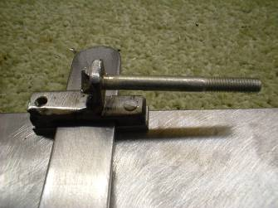
Weld
Bolt 30mm long minimum
20mm

5. Pendulum:-

Cut a strip of material 20mm wide by 195mm long. Accuracy on this is not important.

Fulcrum Bracket:-

Cut a strip of material 10mm wide and bend it into a ‘U’ shape as below:-

12mm

20mm

Weld this to the top of the pendulum as shown in the next photograph. Clean off the excess weld and splatter with a file.
In the centre of the fulcrum bracket, drill a clearance hole for the 30mm minimum long bolt 8mm from the back of the pendulum.
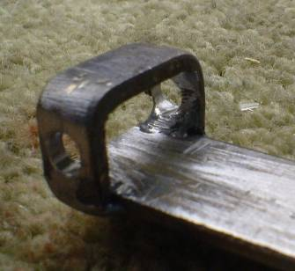
8mm

Place the pendulum onto the fulcrum bolt and check that is hangs vertically and in the centre of the front plate cut-out. If it doesn’t then it can be packed out with washers or bent to the correct position.
The pendulum assembly when it is completed (not now) is finally attached to the fulcrum bolt with washers and a locknut so that is completely free to pivot..
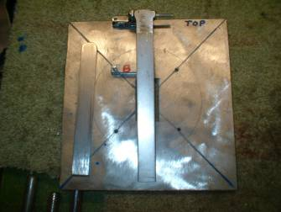

Pellet Striker Bracket:-

Bend a 20mm wide strip of material to the following dimensions:-
42mm

8mm
20mm

Drill and tap two holes at 28mm centres centrally in the top 42mm long part of the striker bracket.

Sacrificial Striker Plate

Cut a strip of material 20mm wide and 42 mm long. Drill two clearance holes centrally at 28mm centres. Bolt this onto the top of the Pellet Striker Bracket.

This sacrificial plate can be easily replaced after severe wear has occurred, although I have never known one to need replacing in the fifteen years I have been making them like this.

Weld this assembly on to the front of the pendulum so that it is central in the slot in the front plate. The top face of the bracket should be 80mm from the top of the pendulum to make it central.

80mm

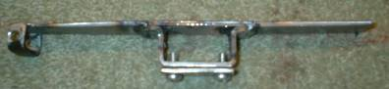

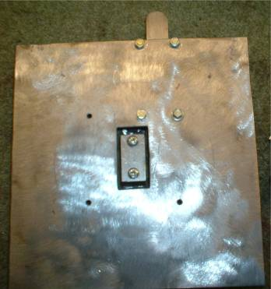
With the pendulum fitted onto the fulcrum bolt the striker should be central in this aperture.
Sears:-

You may have to use a bit of ingenuity here in choosing the correct materials to make these out of. The material must be hard tool steel or similar. Items than can be used are old drills, reamers or taps that can be ground down to the correct size and shape. I myself get friends in Engineering to get me old Tungsten Carbide tool tips from lathes etc that would otherwise be thrown away. These are triangular in shape 20mm on the sides and 4.5mm thick.

One is welded onto a 20mm wide strip 27mm long and the other onto a piece of 20mm wide strip by 40mm long as shown in the next photograph.
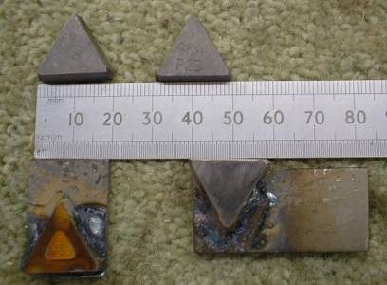
The one on the left is for the plunger, and the one on the right is for the pendulum.

Weld the plunger sear flush with the bottom of the plunger and the pendulum sear inside and at the bottom of the Striker Bracket, flush with the left hand side of it and slightly inclined at an angle of five to ten degrees to the vertical as shown in the photographs.
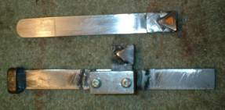
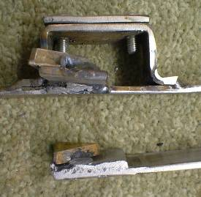
Note Angle of Sear to Pendulum.
Lower Plunger Spring Bracket:-

Bend a 20mm strip of material into an ‘L’ shape to the following dimensions and 16mm from the base drill a clearance hole to suit the plunger spring guide rod. I usually make this from a 4” or a 6” nail if I don’t have a piece of 6mm to 8mm diameter bar handy:-
Clearance Hole

25mm

16mm

18mm

This is then welded to the bottom plunger guide as in this photograph
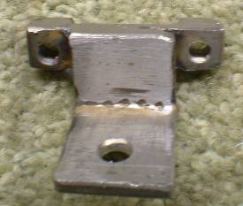

Upper Plunger Spring Bracket:-

Bend a 20mm strip of material into an ‘L’ shape to the following dimensions and 20mm from the base drill a clearance hole to suit the plunger spring guide rod.

Clearance Hole

29mm

20mm

22mm

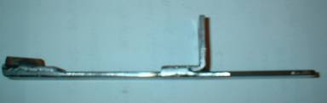
This is then welded onto the plunger in the position shown. This is quite critical as this bracket dimensions and position on the plunger governs the plunger stroke at the top and the distance that the two sears clear each other by at the bottom (The plunger over-travel.)
55mm
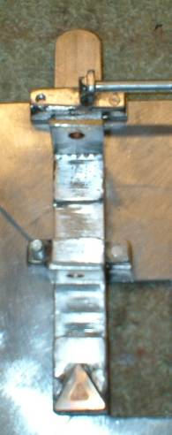
This picture shows the assembly of the plunger spring brackets

After the welding operations clean off excess weld and splatter and ensure that the heat generated has not distorted the plunger. If it has distorted then straighten it out and ensure it is still a loose sliding fit in the top and bottom plunger guides.

Note:- From this point on, to remove or fit the plunger assembly the bottom plunger guide must be dismantled and re-assembled with the plunger between the two pieces.
Top Spring Bracket
Bottom Spring Bracket

Plunger Spring Guide:-

Cut a piece of rod 6mm to 8mm in diameter (or a 4” or 6” nail as previously mentioned – I have used a 4” nail here) to a length of 85mm and round off both ends.

I have turned up a spring bush and welded it in position 12mm from one end, but a plain washer welded in the same position will work just as well.
12mm

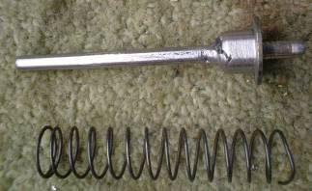

Choose a spring of the appropriate length and diameter. It should not be too strong. This assembly then slips between the top and bottom plunger spring brackets, placing the top end in first and then slipping the bottom end in.

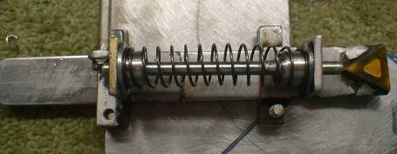

Sears Engaged – Plunger Down Ready for Shot.
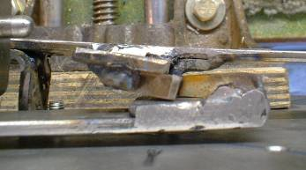
Pendulum Sear
Plunger Sear

Sears Disengaged – Plunger Up.
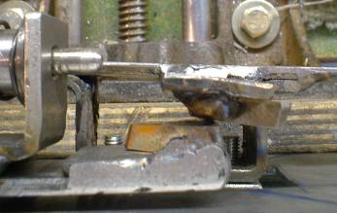
Pendulum Sear
Plunger Sear

Total Travel of Plunger

15mm

Adjuster Bracket:-

Bend a strip of 20mm wide material into an ‘L’ shape:-

20mm

Weld this to the bottom of the Pendulum Assembly as shown in the photograph with the 20mm length across the width of the pendulum:-

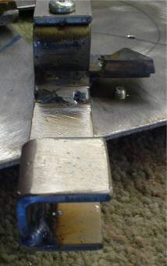

Place the pendulum into its finished position on the front plate, ensuring that the Pellet Striker is central in it’s cut-out.

Mark the position of the Adjuster Bracket bottom face onto the Front Plate.

In the centre of this position on the front plate, drill and tap a hole for an adjuster screw and locknut.

This will allow you to set the sear depth engagement so that the plunger is released at the required pellet strike.

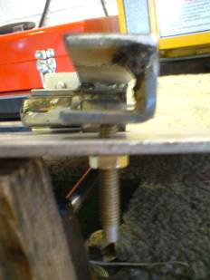
Pendulum In Final Position on Front Plate

Adjuster Bracket welded into position

Locknut

Adjusting Screw

Pendulum Tension Spring Bracket:-

Bend a 20mm wide strip to the following dimensions:-

40mm

27mm
24mm

Drill a clearance hole in the centre of the top face for the pendulum tension spring guide and two clearance holes in the bottom face for fixing bolts. See photograph:-

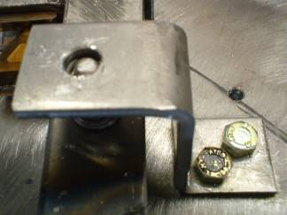
Clearance Hole for Pendulum Tension Spring Guide

Clearance holes for Fixing Bolts.

Pendulum Tension Spring Guide:-

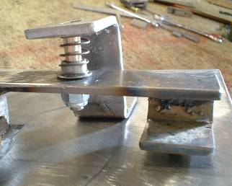
Drill a clearance hole in the centre of the 20mm wide pendulum, 40 mm from the bottom end.
Fit a bolt through as shown and lock in place with two locknuts. Cut the top of the bolt off to leave 15mm protruding from the back face of the pendulum.

Position the clearance hole in the top face of the pendulum tension spring bracket centrally over the guide in the pendulum. Mark the position of the two fixing holes on the front plate. Drill and tap these holes.

Chose a spring of suitable tension so that when the assembly is complete the plunger spring tension can overcome the pressure applied by the pendulum tension spring and the two sears slide over each other when the plunger is allowed to slowly travel it’s complete stroke.
15mm

40mm

Bell Mechanism:-

For the bell I use a bicycle bell top. I tap the inner thread of the bell top out 2BA and then drill and tap the front plate in a convenient position and screw in a 2BA bolt. The bicycle bell top is then screwed directly onto this bolt.

Legs:-

From 20mm wide strips make 4 legs minimum 45 mm overall length to suit the target box and weld them onto the four back corners of the front plate. See photograph.

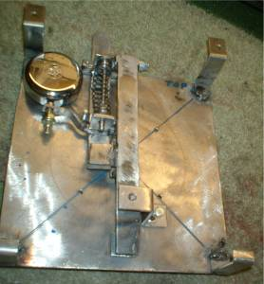
Legs welded in corners
Bicycle Bell Top

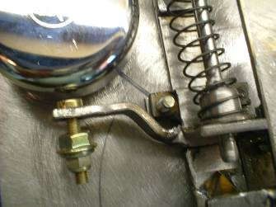
Bell Striker Arm
Bell Striker

The bell striker is not to be solid against the bell or no ring will be heard, only a dull thud…… The striker is made from a bolt through a clearance hole in the Bell Striker Arm with two locknuts on the bottom to give it some mass. The theory being that when the plunger stops at the end of it’s stroke, the striker carries on upwards under it’s own momentum, strikes the bell and then falls back leaving the bell clear to ring.

The shape of the striker arm which is made from an 8mm wide strip will have to be developed by yourself when you have mounted the bell.

Target Plate Pillars:-

These can be made from any bar material. I used ½” A.F. hexagonal brass bar for the simple reason that I had it handy. Cut four lengths 24mm long. Make them as close in length to each other as possible. Drill them through and tap through with a 2BA thread. Use this as most target plates are made for the 2BA diameter screws and 5mm screws will not go through them. Fix the pillars to the front plate with 2BA screws 10mm long (3 off) and one long enough to go through the left hand bottom guide bolt hole that you now drill out as clearance and goes 8mm into the fourth pillar.
Now screw on the target plate and you should have a Bell Target that will last many, many years.

Finally:- A coat of ‘Hammerite’ type paint covers over a multitude of sins thankfully, as my welding is not the neatest I have ever seen.

Good Luck……………………………………
Larger Photographs of Finished Target Mechanism:-

Back Complete

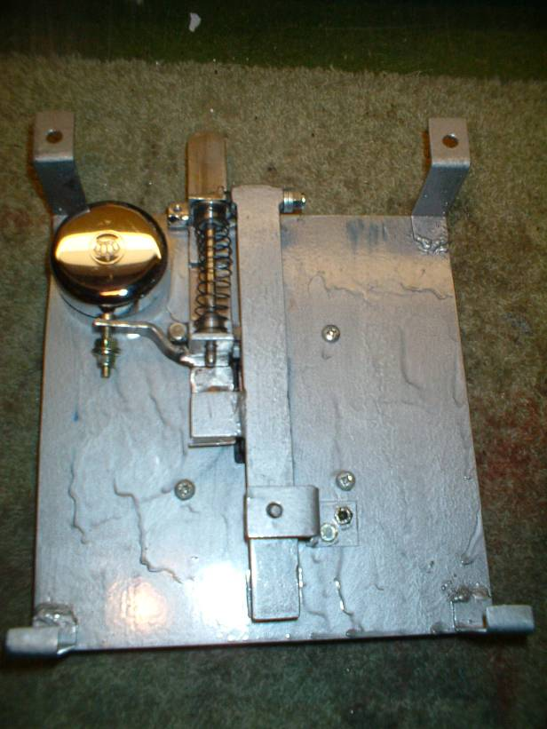

Front Complete:-

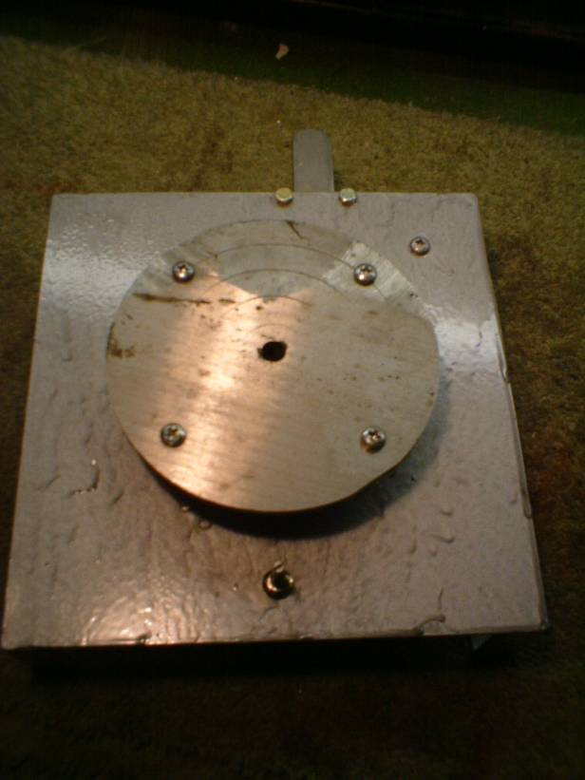

Adjuster – Slightly Out Of Focus…….

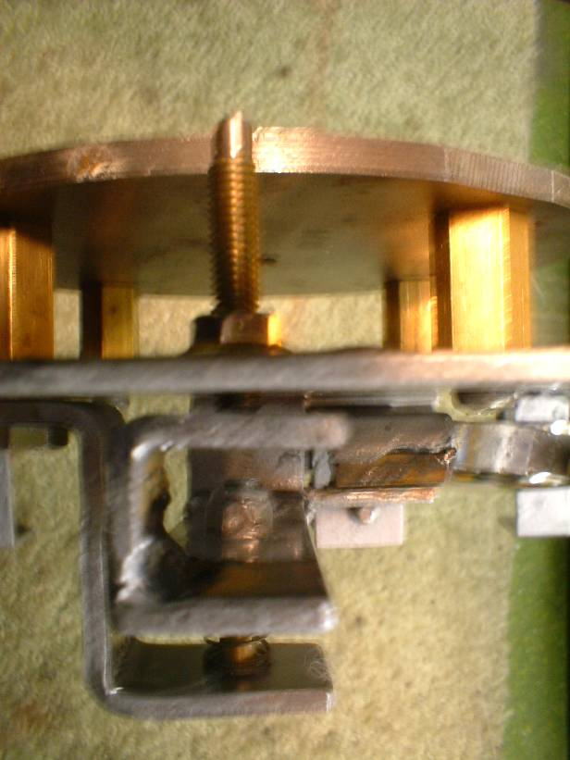

Complete Mechanism:-

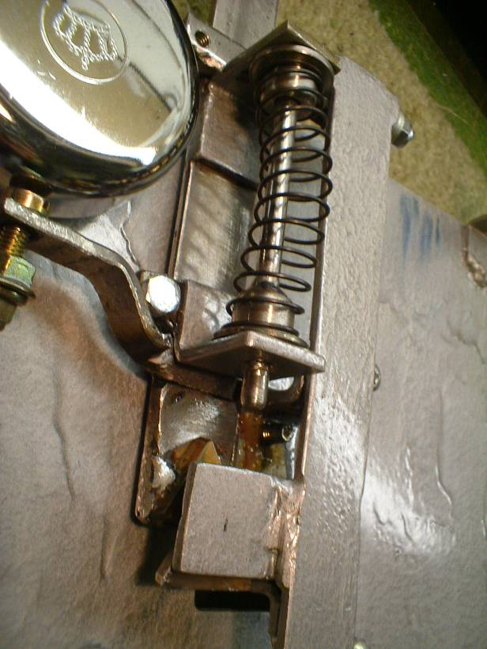

Pendulum Spring and Guide Assembly:-

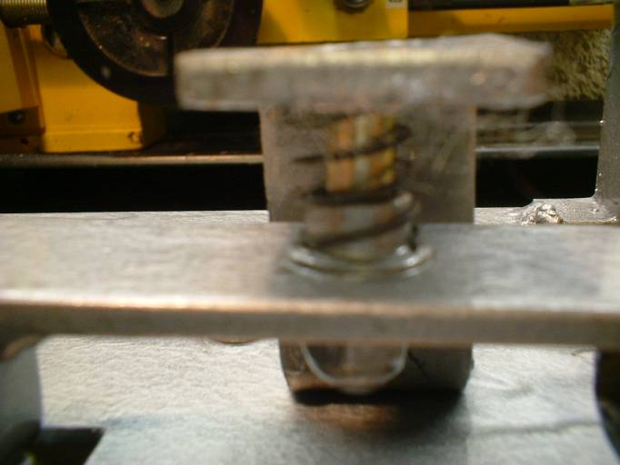

Side View Showing Faceplate Pillars:-

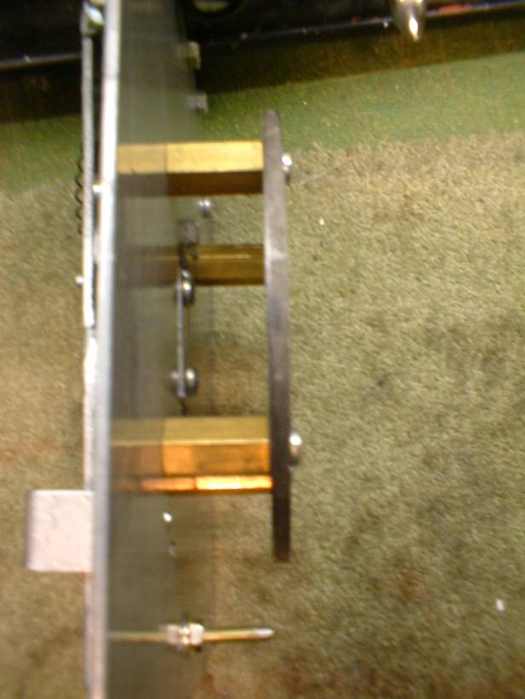

Bell Striker Showing Gap:-

